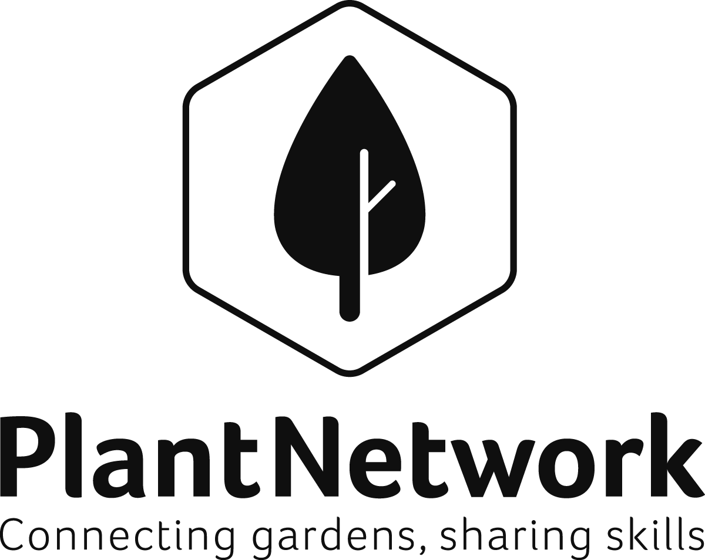

Manging gardens and plant collections within universities and other institutions Training Day
19th October 2017
Treborth Botanic Garden, North Wales

@plantnetwork

Programme
9.30 | Registration and coffee at Treborth
9.40 – 10.15 | Welcome and introductions.  What would attendees wish to lean from today?
10.00 | Case studies on managing gardens and collections for research, partnerships & visitor attraction  Thinking Beyond the Campus Lee Hale, Head of Winterbourne House and Garden, University of Birmingham  Botanic gardens in local authority ownership Ian Turner, Curator, Sheffield Botanic Garden  Treborth botanic garden; the power of volunteers Natalie Chivers, Curator of Treborth Botanic Garden
11.30 – 12.00 | Questions and discussion
12.00 | Tour of Treborth  Natalie Chivers, Curator of Treborth Botanic Garden
13.15 LUNCH
14.00 | Developing management plans and Spirit of Place that helps to relate collections to host institutions core aims. Pam Smith. Garden Adviser National Trust
14.30 | Discussion, next steps
15.30 | Close
All presentations from our training and conferences are shared through our website. www.plantnetwork.org. Our website search facility also allows you to find previous newsletter articles, presentations and downloads. As always, please get in touch if you have any suggestions for website content.

Speaker Biographies
Natalie Chivers Curator, Treborth Botanic Garden, University of Bangor
Natalie gained a MEnvi in Environmental Science from Bangor University before training with the Royal Horticultural Society and Gothenburg Botanic Garden. She then studied for an MSc Plant Conservation at Bangor before starting as Curator in August 2015.
As Curator of the Garden, Natalie has the responsibility for managing the living collections, which comprise over 2000 species. Her key areas of responsibility include planning the future direction of the collections, overseeing the sourcing and documentation of new and diverse species, driving the landscaping and design of the garden and promoting the use of the collections for research and teaching. Natalie was co-opted to the Board in June 2017.
Ian Turner
Service Manager, Parks and Public Realm, Curator, Sheffield Botanical Gardens
Ian has 30 years of experience working in both the private and public sector. He came to Sheffield in 2008 following 11 years as Curator of Plants for Paignton Zoo. Sheffield Botanical Gardens underwent a complete HLF funded restoration which was completed in 2005. The gardens have continued to develop, with the Dorothy Fox Education Centre being the latest addition in 2017. The gardens form part of the Parks and Countryside portfolio of green spaces across the city. Since 2015, in addition to his curatorial role for the gardens, Ian also has responsibility for managing parks, open spaces and grounds maintenance operations across the city.

Lee Hale Head of Winterbourne (Director)
Lee first started his career at Birmingham Botanical Gardens as a horticultural apprentice which was followed by further study at Pershore College of horticulture. Lee’s love of nature and gardens have always ensured horticulture and heritage sectors jobs in various locations across the UK. Lee returned to Birmingham to take on a horticultural supervisor/lecturer role in the late 1990’s and now manages Winterbourne House & Garden a 7 acre arts and crafts period site owned by the University of Birmingham. Following refurbishment of the Edwardian house in 2010 Winterbourne now welcomes over 70000 visitors a year from all over the UK. The site is an RHS Partner Garden, RHS training Centre, Historic Houses Association member and as of 2017 a fully accredited Arts Council museum. The site is also a member of the Visitor Attraction Quality scheme (VAQAS) and is consistently rated as a Birmingham top ten attraction. Lee’s work at Winterbourne has also allowed for the development of further interests which in turn have supported academic research and public engagement. These include The Arts and Crafts movement, Pre-cinema entertainment and late 19th to early 20th century print. Lee is an active member on several committees including Growing Birmingham and The Centre of Printing History and Culture.

Pam Smith Administrator PlantNetwork and Gardens Consultant at National Trust
Pam was Vice Chair of PlantNetwork before taking up the part time role of PlantNetwork Administrator in 2013. She also works part time for the National Trust Midlands Region as a Gardens Consultant.
Pam has worked in horticulture for over 30 years and trained via a YTS programme in Bangor and an OND at Askham Bryan College. In 2000 Pam gained a PG Diploma with the Architecture Association in Conservation and Management of Historic Landscapes, specialising in 19th C Natural History exhibits in public parks. Her career started with 11 years in north east public parks followed by 8 years as Director of Winterbourne, the University of Birmingham Botanic Garden. She later worked as a freelance horticultural and heritage consultant before joining the National Trust in 2011 where she advises properties on garden management, projects, staffing and presentation standards. She is currently working on three 18th C Pleasure Ground restorations, two walled garden restorations and a project to assess and promote botanical heritage within the Trust’s gardens, collections and archives.

RESOURCES
COLLECTIONS MANAGEMENT
The PlantNetwork Directory of Botanical Collections in Britain and Ireland
First published in hard copy in 1999. The Directory, with some updates, is now available online but there are many records out of date. Please update the entry for your garden in the Directory at:
www.plantnetwork.org/resources/directory
Scroll down to the list of gardens, click on your garden.
Scroll to the end of the entry for your garden and click on the link to download a copy. Make any changes, save the file and post it to Rupert Wilson, or send it to him as an email attachment.
If you need any help with either method, please contact Rupert. rupertwilson@rhs.org.uk

Plant collecting and conservation: Garden and Collections Management - Legal Frameworks and processes

The Convention on Biological Diversity (CBD)
Opened for signature at the Earth Summit in Rio de Janeiro in 1992, and entering into force in December 1993, the Convention on Biological Diversity is an international treaty for the conservation of biodiversity, the sustainable use of the components of biodiversity and the equitable sharing of the benefits derived from the use of genetic resources. With 196 Parties up to now, the Convention has near universal participation among countries. The Convention seeks to address all threats to biodiversity and ecosystem services, including threats from climate change, through scientific assessments, the development of tools, incentives and processes, the transfer of technologies and good practices and the full and active involvement of relevant stakeholders including indigenous and local communities, youth, NGOs, women and the business community. The Cartagena Protocol on Biosafety is a subsidiary agreement to the Convention. It seeks to protect biological diversity from the potential risks posed by living modified organisms resulting from modern biotechnology. To date, 170 Parties have ratified the Cartagena Protocol. The Secretariat of the Convention and its Cartagena Protocol is located in Montreal.
www.cbd.int

The Nagoya Protocol
The Nagoya Protocol on Access to Genetic Resources and the Fair and Equitable Sharing of Benefits Arising from their Utilization to the Convention on Biological Diversity was adopted at the tenth meeting of the Conference of the Parties in 2010, in Nagoya, Japan, and entered into force on 12 October 2014. The Protocol significantly advances the objective of the Convention on the fair and equitable sharing of benefits arising from the utilization of genetic resources by providing greater legal certainty and transparency for both providers and users of genetic resources. By promoting the use of genetic resources and associated traditional knowledge, and by strengthening the opportunities for fair and equitable sharing of benefits from their use, the Protocol will create incentives to conserve biodiversity, sustainably use its components, and further enhance the contribution of biodiversity to sustainable development and human well-being. To date, 68 Parties have ratified the Nagoya Protocol.
The full text of the Nagoya Protocol is available at:
Nagoya protocol on access to genetic resources and the fair and equitable sharing of benefits arising from their utilization to the convention on biological diversity; text and annex
© 2011 by the Secretariat of the Convention on Biological Diversity. To download: www.cbd.int/abs/doc/protocol/nagoya-protocol-en.pdf

Information on Access and benefit Sharing (ABS)
The ABS-Clearing-House https://absch.cbd.int/ BGCI webpages www.bgci.org/resources/abs/ EU Regulations: http://ec.europa.eu/environment/nature/biodiversity/international/abs/index_en.htm You Tube ABS Simply Explained

Material Transfer Agreements (MTAs)
A Material Transfer Agreement (MTA) is a document used to outline the terms under which material is supplied. CBD-friendly MTAs generally set out permitted uses of material, terms for supply to others, requirements for benefit-sharing, and usually, non-commercialisation. Many gardens now use a standard form, to which extra terms can be added where necessary (for example if the material was acquired under a more restrictive permit).
Extract from Botanic Gardens Conservation International www.bgci.org

International Plant Exchange Network (IPEN)
A model for the acquisition and the exchange of living plant material within the botanic gardens community in respect of the ABS requirements of the CBD. IPEN is a voluntary registration system intending to facilitate the botanic gardens plant exchange in accordance with the CBD provisions. IPEN is characterised by the following aspects:
- only for botanic gardens according to the definition by the BGCI
- IPEN covers only the exchange of living plant material, meaning living plants or parts of plants
- only for non-commercial exchanges: Plants must not be sold for profit or used for any kind of commercial activity
- IPEN includes a documentation system (IPEN numbers, that makes the origin of the plant material traceable at any stage of plant exchange
The backbone of the network is the IPEN Code of Conduct, a three-page document stating the unified policy of the IPEN member. This covers acquisition, maintenance and supply of living plant material by the gardens as well as benefit-sharing. The Code further provides a Material Transfer Agreement (MTA) to be used for exchanges with institutions that are not member of the IPEN network.
Abstract from www.bgci.org
ThreatSearch
The most comprehensive database of conservation assessments of plants. Organised and hosted by Botanic gardens Conservation International.
- Search over 242,000 conservation assessments, representing over 150,000 taxa.
- Find out if a plant has a global or regional conservation assessment
- Find out if a plant is considered threatened
www.bgci.org/threat_search.php
For more information on CBD, Nagoya Protocol and ABS please go to our website and also look at our Nagoya Training Day resource booklet from 2015 and our Resouce booklet from the 2015 Nottingham conference.
We will be holding an ABS and Nagoya training day in 2018

DEVELOPING STRATEGIES FOR YOUR GARDEN
Action Plan for Botanic Gardens in the European Union
There are around 800 botanic gardens in Europe and in most countries these are linked through national botanic garden networks, of which PlantNetwork is one.
The Action Plan sets out for botanic gardens in the EU more than 30 objectives on science and horticulture; heritage and culture; conservation of biodiversity; education, training and awareness; networking and co-operation; capacity building; and funding to implement the Action Plan. It provides an EU wide framework and shared set of priorities and defines a role for botanic gardens in the 21st century, with common agreed targets. Its purpose is to provide a methodology for examining an institutional response: What is its mission, is it clearly understood and defined; what are its roles in botanical research, conservation, education and horticulture; can all staff be involved in the preparation of a response to the action plan?
The Action plan, currently under revision, provides an opportunity for gardens to review current policies, management practices, procedures, management, resources and facilities. It is an ideal base from which to develop your policies, management plans and plan future projects and is relevant to all gardens, not just botanic gardens. It is a good starting point to help develop your mission statement, define core aims and by contributing to some of the plan’s objectives will help raise the profile of your garden.
www.botanicgardens.eu/action/actionplaneu.htm

Collection Policies
A Collection could include living plants and fungi including seed, pollen and spores; herbarium specimens; DNA; reference material derived from scientific study, e.g. chromosome slides; economic botany artefacts; accompanying literature, i.e. libraries and archives. The collection could be as large as the entire holdings of a botanic garden with an institute mission and linked to a national or international network. Alternatively, it may be just one of several collections in a botanic garden. Its purpose could be singular or multi-disciplinary. It could be historical, recent or proposed and be of varying size and resources.
A Collection Policy is a written document which acts as a practical management tool by defining the limits of the collection and guiding the actions of its manager through future developments. It should embrace the remit of the organisation; be formulated using a clear methodology; be practical, achievable and flexible; be subjected to constant review and, if necessary, revision.
Dr David Rae RBGE BGCI Magazine Plant Collection Policy-are Guidelines Needed? Volume 2 Number 6 - June 1996
More information on managing plant collection management is available in our 2015 Annual conference resources booklet ‘Plant collections management; keeping it legal, ethical and relevant’ available on our website.

The Darwin Technical Manual for Botanic Gardens
A clear and concise technical handbook for the management of botanic gardens bringing together current knowledge and practice of managing a botanic garden. Packed with detailed information on everything you need to know about creating and running a botanic garden, this is a unique resource.
The manual was developed in 1998 as part of a project funded by the Darwin Initiative, and is given to all new Botanic Garden Members as part of the Botanic Garden Resource Pack.
The Darwin Technical Manual for Botanic Gardens - Etelka Leadlay and Jane Greene (eds), 1998 Botanic Gardens Conservation International (BGCI), London, U.K. ISBN 09520275 6 9
Order from BGCI £14.00 plus post and packaging
http://www.bgci.org/resources/darwin_manual/

From Idea to Realisation – BGCI’s Manual on Planning, Developing and Managing Botanic Gardens (2016)
Recognising the ever-increasing needs and requests for technical guidance on botanic garden development and management, BGCI has been working on the establishment of a new botanic garden manual since late 2013. Building on The Darwin Technical Manual for Botanic Gardens (Leadlay and Greene, 1998) developed at that time with the generous support by the Darwin Initiative - a major UK government biodiversity grants scheme - this new resource From Idea to Realisation – BGCI’s Manual on Planning, Developing and Managing Botanic Gardens (2016) is a direct response to the growing importance, sophistication and complexity of the international botanic garden community over the last two decades. As key custodians of global plant diversity, this central role and endeavour of botanic gardens and arboreta is as pivotal as ever in times of rapid, worldwide change and unabated biodiversity loss.
This Manual is intended for botanic gardens and arboreta as ever-evolving institutions that respond to environmental and societal needs, changes and challenges. It is not meant to be prescriptive but to offer guidance and ideas with case studies from around the world. As a comprehensive resource, the guidance provided aims at newly developing institutions with limited experience as well as at established botanic gardens that may seek advice or information for instance as part of a re-development or an organisational review.
As this is a living document, feedback will be invaluable to ensure that the guidance and information provided meets its purpose and evolves over time to remain relevant to the botanic garden community.
https://www.bgci.org/resources/2016-bgci-botanic-garden-manual/

PARTNERSHIPS
There are a number of National and International days that relate to gardens and plant collections. Planning an event to link with these celebratory days is a great way of being part of something bigger. Of particular relevance is the International Day for Biological Diversity, held on 22 May each year. The day was initiated by The United Nations in 1993.
The International Day for Biological Diversity (IDB) to increase understanding and awareness of biodiversity issues. The theme for 2017 is Biodiversity and Sustainable Tourism
This theme has been chosen to coincide with the observance of 2017 as the International Year of Sustainable Tourism for Development as proclaimed by the United Nations General Assembly in its Resolution 70/193 and for which the United Nations World Tourism Organization is providing leadership.
www.cbd.int/idb/2017/

Citizen Science Projects
Citizen science – the involvement of volunteers in science – isn’t new. Within the UK we have a long and rich tradition of scientific discovery by unpaid individuals and interest groups. Indeed our current understanding of UK wildlife and the wider environment is due in large part to the dedication and expertise of the naturalist community. Over the past decade, there has been a rapid increase in the diversity and scale of citizen science. Initiatives range from crowd sourcing activities, in which the time and effort of large numbers of people are used to solve a problem or analyse a large dataset, to small groups of volunteers, who are experts in their own right, collecting and analysing environmental data and sharing their findings. The range of possible approaches can be bewildering, but when it is planned and executed well, citizen science can increase scientific knowledge, raise people’s awareness of their environment and allow like-minded people to share enthusiasm and knowledge (extract from The UK Environmental Observation Framework).
The UK Environmental Observation Framework
The UKEOF works to improve coordination of the observational evidence needed to understand and manage the changing natural environment. Their website includes a number of resources to support Citizen science projects such as contracts, cost benefit analysis and evaluation reports. It also includes a number of case studies, including the RBGE Phenology projects.
http://www.ukeof.org.uk/
UKEOF ‘Guide to Citizen science’ available from:
http://www.environment.scotland.gov.uk/get-involved/toolkit-useful-links-and-case-studies/
More citizen science resources available to download from: http://www.environment.scotland.gov.uk/get-involved/toolkit-useful-links-and-case-studies/

Observatree
Our aim is to protect the UK’s trees, woods and forests from new pests and diseases – either arriving or spreading across the country. The earlier these are spotted, the higher the chances that outbreaks can be eliminated or controlled.
We encourage tree health professionals and people actively involved with trees to act as citizen scientists and report potential sightings of anything worrying. More eyes on the ground means a greater chance of earlier detection. A wide range of resources and training materials are available to help improve knowledge of our priority pests and diseases.
Concerns should be submitted to Tree Alert in the first instance. Find out more about how to report a new pest or disease using Tree Alert.
www.observatree.org.uk
Measuring and demonstrating the wider impact of what you can deliver.
Inspiring Learning for All (ILFA) is a planning and evaluation toolkit developed by Arts Council for use with cultural and heritage organisations and activities. It has been used successfully by many organisations across the UK including the Tate, English Heritage, BBC, the British Museum and the national museums of Wales and Scotland.
ILFA supports your organisation to:
- assess its strengths and plan improvements
- provide evidence of the impact of your activities through the generic learning & generic social outcomes
- improve your strategic and operational performance
- identify best practice
- demonstrate your impact

Overall it helps you to measure and evidence the wider benefits of your activities
The Inspiring Learning for All framework is built on a broad and inclusive definition of learning, adapted from the Campaign for Learning.
It identifies that:
- learning is a process of active engagement with experience
- it is what people do when they want to make sense of the world
- it may involve the development or deepening of skills, knowledge, understanding, values, ideas and feelings
- effective learning leads to change, development and the desire to learn more
To be a learning organisation, you should develop and encourage:
- a shared vision of your organisation’s role and purpose
- initiative, team work and flexible approaches
- personal and professional development
- openness to new ideas and approaches
Generic Learning Outcomes (GLOs)
Assist you in measuring and providing evidence relating to how you deliver Knowledge & Understanding, Activity, Behaviour & Progression, Enjoyment, Inspiration, Creativity and help to change Attitudes & Values
Generic Social Outcomes (SLOs)
assist you in measuring and providing evidence of the wider benefits of your art and cultural activities. They do this by helping:
- demonstrate how art and culture organisations support wider-community benefits
- demonstrate a contribution to social cohesion, health and well-being
- demonstrate a link to wider local and national priorities
Setting outcomes is at the heart of service planning and improvement. The GSOs also support service improvement by helping you to:
- plan projects, set objectives and assess delivery against them
- develop best practice
- align to shared outcomes for local people and wider-policy priorities
- develop reflective practitioners
- encourage partnership working through shared priorities

http://www.artscouncil.org.uk/advice-and-guidance/inspiring-learning-all-home-page

NOTES

